All of that and more – My experiences of the phrase ‘high functioning’

Words matter
The words we use to describe each other matter. People use lots of different words to describe me but some of them make me very uncomfortable.
When people use words like ‘high functioning’, I think they make lots of assumptions about me and my experiences. These assumptions can be harmful and inaccurate.
Everyone is unique. While it can be useful to describe similarities between people, it is important to use respectful words that people are comfortable with.
I want people to use words that reflect all of my experiences, both the easy and hard parts.

All of that and more
I often get the same comments from strangers.
“You’re so high functioning!”
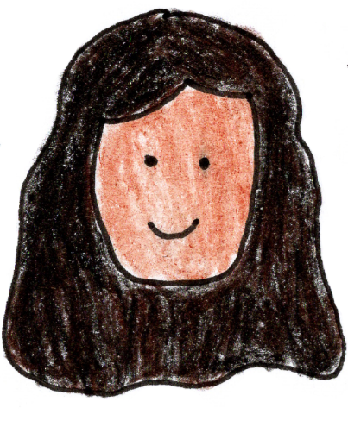
I wonder why some people say that? I wonder what my disability seems like to other people?

Some people only get to see:
- Articulate
- Good memory
- Energetic
- Busy
- Clever
- Kind
Some people only get to see:
- Complex needs
- Vulnerable
- Challenging behaviours
- High risk
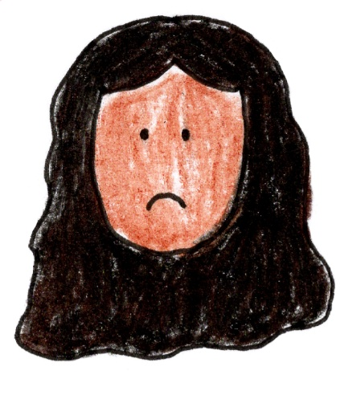
- Extreme difficulties

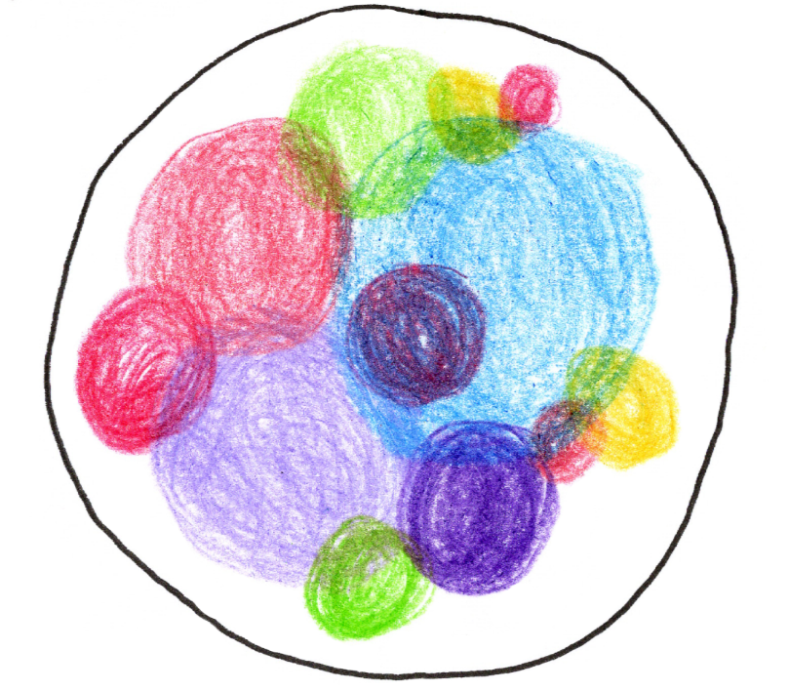
In reality, I am all of that and more:
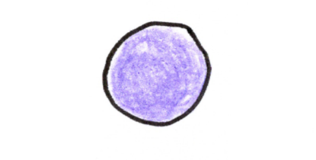
When you meet me in one place, you only see a little part of me.

From one part, you can’t judge my whole life. My disability and life change a lot. You often can’t tell how well or unwell I am from looking at me.
I don’t like using words like ‘high functioning’ or ‘low functioning’. People have such varied lives. These words unfairly compare people.
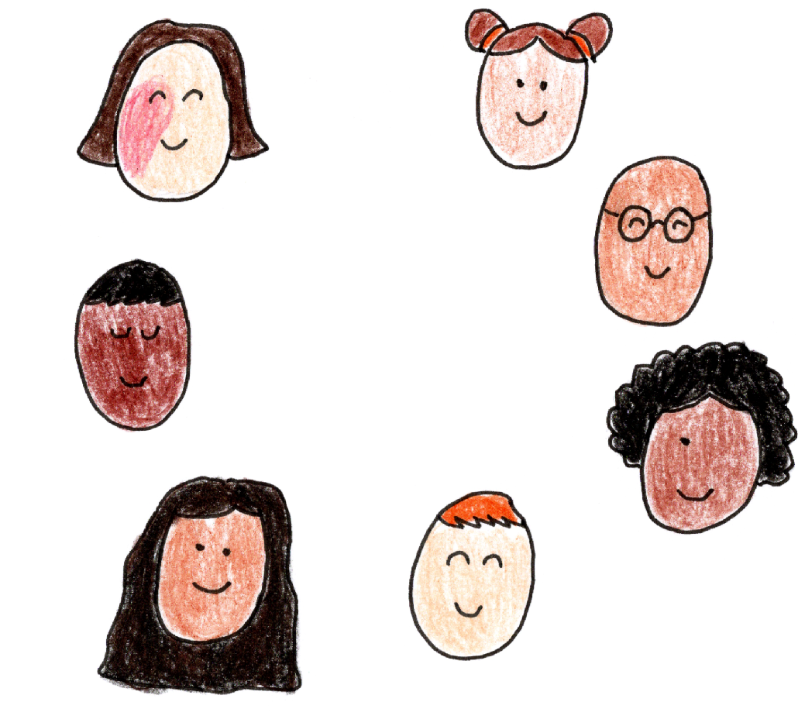
There are so many other words that we can use to describe other people. When talking about me, people can say:
- Spikey profile
- Variable support needs
- Dynamic disability
- Communicates best using writing
- Needs help sometimes, not others

Questions
What do you think about the phrase ‘high functioning’? Has anyone ever used it to describe you?
What ways do people compare you to others? How would you change those comparisons?
What inaccurate assumptions do people make about you?
What ideas and systems are phrases like ‘high functioning’ related to?

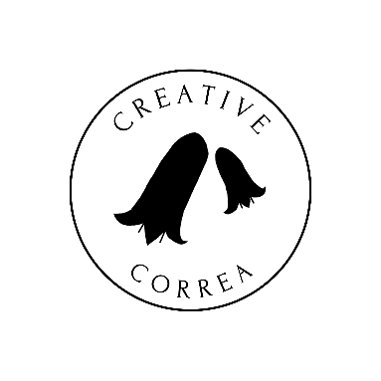
Credits

Creative Correa
enquiries@creativecorrea.au
Made by Sudhashree Somers
2026

