Disability Difficulties

Being disabled can be difficult
My brain and body have worked the same way for a very long time. I always struggled but I didn’t identify as a disabled person until later in my life, when I needed extra help.
Being disabled can be hard for many reasons. I never realised how difficult it can be. My life has become complex to navigate, and it’s often because of things put in place to help me.
I find getting help to be unexpectantly hard. It can get really frustrating, often more frustrating than the impact of my disability.

Disability difficulties
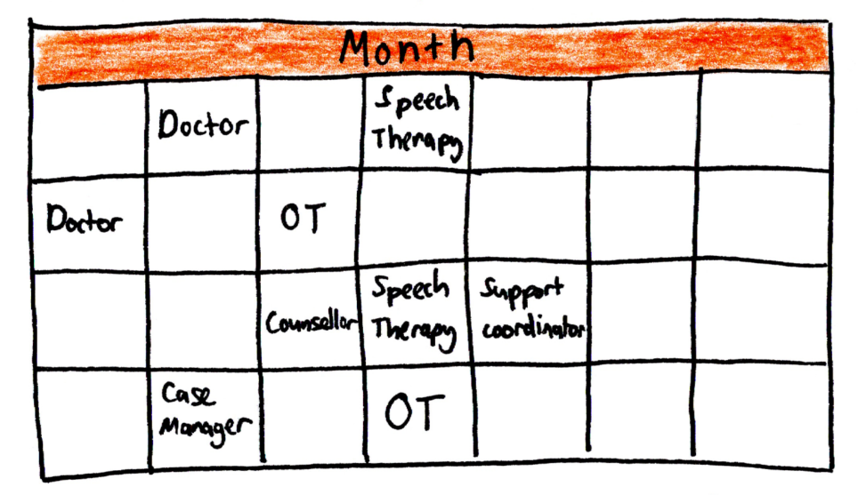
I knew that disabled people had doctors and therapists, but I didn’t realise how much effort it would take.

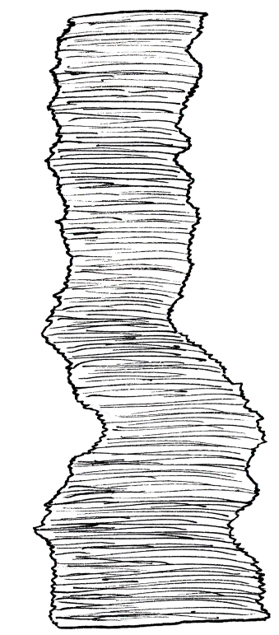
I have to manage a truly astounding amount of PAPERWORK!

- Medical records
- Therapy worksheets
- Case Notes
- Applications
- Plans
- Notes
It’s never ending.

It often feels like everything I do requires a goal, which comes with more paperwork.
“My goal is to have no goals, I want to live my life.”
“Sorry, that’s not allowed, could you turn that into a goal?”
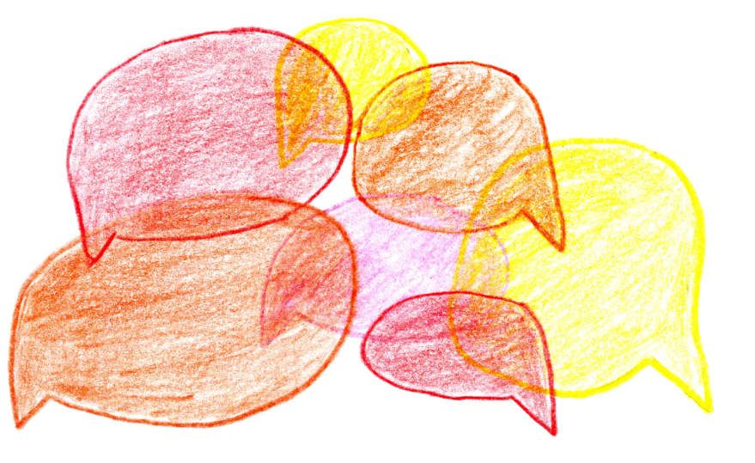
Each decision I make requires the input of multiple people.

They don’t always agree.
Sometimes getting help can take a lot of energy. I could have spent that energy managing my disability.
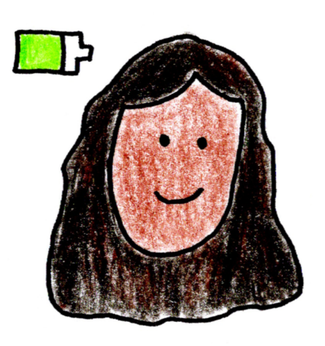
“I need help. Could you help me?”
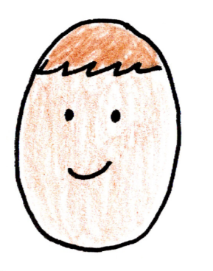
“To get help from me, I need you to explain all the worst days of your life, and fill in these forms, and…”

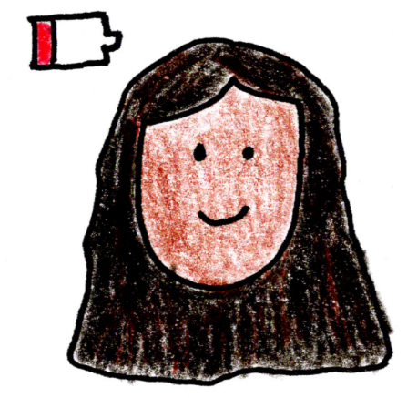
“I could have used this energy to make dinner.”

My life often feels like it is controlled by complete strangers. I feel very lonely.

Questions
What parts of your life are surprisingly hard?
What frustrates you about hard parts of your life?
If you could, how would you change the hard parts of your life?
What skills and knowledge do you use to navigate the hard parts of your life?


Credits
Creative Correa
enquiries@creativecorrea.au
Made by Sudhashree Somers
2026

