Disability Identity

Disability is diverse
People can be unsure how to refer to a person with disability, or a disabled person. They might make assumptions or be scared to use the wrong language.
People have diverse experiences of disability. There are multiple ways a person might describe themselves. Different people will describe themselves differently. One person might identify differently across their life.
If you are unsure how a person identifies, just ask!
How do you describe your identity?
Do you identify as disabled or a person with disability? Why/why not?
How has the way you describe yourself changed over time?

Disability identity
The disability community is very diverse. There are lots of people with lots of different experiences. There are two main ways to describe someone in this community:
- Person first – person with disability
- Identity first – disabled person
Someone might prefer ‘person with disability’ because it emphasises that they are a person. They might want to be seen as more than just their disability.
Someone might prefer ‘disabled person’ because they think that disability is an important part of their identity,

“I prefer to say I’m a person with disability, because I want others to see me as more than just my spinal cord injury.”
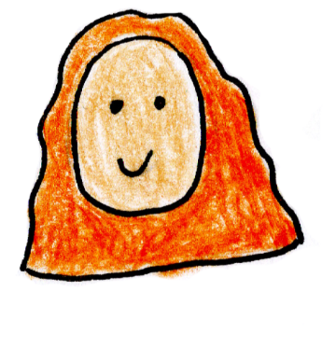

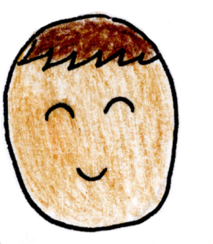
“I’m disabled, Indian and gay. I’m proud of my identities, they are all different aspects of who I am.”

Some people might not identify as disabled at all!

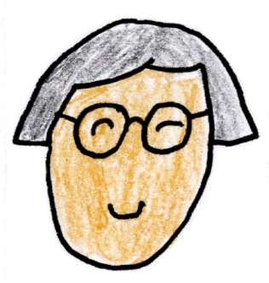
“I’m proudly Deaf. I use Auslan and I’m involved in Deaf culture. I think of myself as part of a cultural minority, not disabled.”

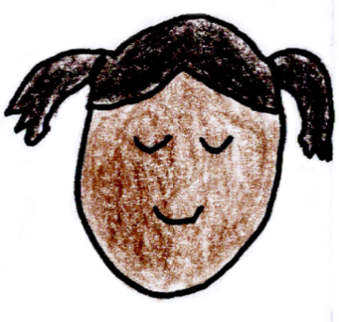
“I have bad arthritis in my knees. I don’t consider myself as disabled but I still need help.”

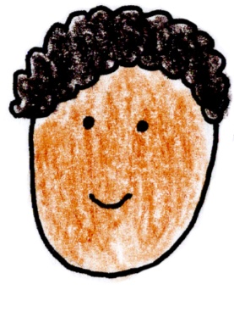
“I don’t know if I should identify as a person with disability. My doctor said I should apply for disability supports, but I don’t know if that means I’m disabled.”

Many Deaf, Hard of Hearing and Autistic people do not identify as disabled or as people with disability. Many people who acquire their disability at an old age may not realise they have a disability.
People’s identity might change over time. Everyone is unique. It is okay for people to identify differently.
When talking about a person, it is best to ask how they prefer to identify.
“I want to check, how do you prefer to describe yourself?”
“I prefer to say I’m a person with a disability and a full-time wheelchair user.”
“Thank you for letting me know.”
Some people might not be able to explain their identity. You could check with their support people, like family or support workers, to see what language they use.
There are language guides created for government documents. These can be useful in using the correct language to describe a specific community. You could also ask a person in that community about what they prefer.
If you make a mistake, correct yourself, apologise and move on with the conversation.

Resources
People With Disability Australia
Australian Federation of Disability Organisations
Australian Government Style Manual

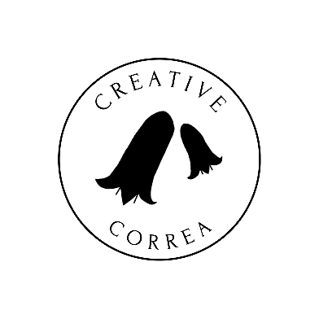
Credits
Creative Correa
enquiries@creativecorrea.au
Made by Sudhashree Somers
2026

